East Asia Civilization
Student Name
Institution Affiliation

East Asia Civilization
Introduction
Civilization refers to the human cultural and social organization and developments which are mostly considered as advanced. This paper focuses on the early civilization of East Asia. This is the region described in either ethno cultural or geographical terms. Geopolitically and geographically, East Asia encompasses China, Mongolia, North Korea, Japan, South Korea, Macau, Taiwan, and Hong Kong. As a cultural sphere, East Asia consists of Japan, Korea, China, and Vietnam (Lai, 2015). This essay draws explanations from Buddhism religion, East Asian art as well as literature and writing. East Asia is considered to be the cradle of civilization in the entire Asian countries like ancient Japan, China, Mongol empire and Korea
Buddhism in East Asia
According to Lai, (2015), Buddhism started in East Asia at around 3 B.C.E. this is the period and century marred with many battles led by very ambitious leaders of the great Maryann empire. These combats were meant to extend the boundaries of the leaders. One of the kings by the name Asoka converted into Buddhism after he was greatly troubled by the subjugations on humanity. He decided to adopt a nonviolence approach, renounced fighting and incorporated Buddhism principles in his practices of the ruling (McDaniel, 2015). The spread of Buddhism was enhanced by Asoka when he decided to send monks to nearby areas to share Buddha’s teachings. A conversion wave began from the rest of India to East Asia.
The main teachings of Buddhism are inscribed in the religion’s four truths which are sukkah (living is suffering), suffering must have a cause which is attachment and craving (Trisha).
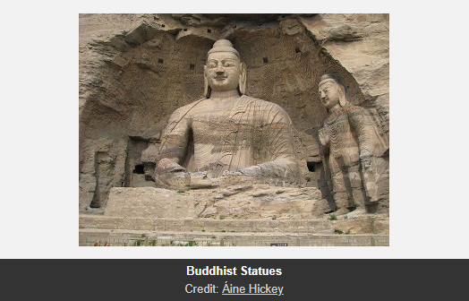
Figure 1.A photo of a Buddhist sculpture
Source: http://www.essential-humanities.net/world-art/east-asian/
Suffering also ceases (nirvana) and there is a trail to the ending of grief: right views, right speech, right resolve, right livelihood, right mindfulness, right action, right effort as well as right concentration.
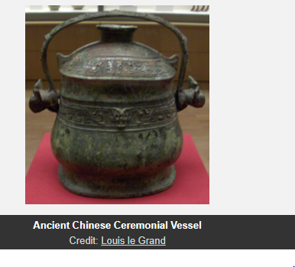
Figure 2 Source: http://www.essential-humanities.net/world-art/east-asian/.
Architectural Design
The main architectural design and art in East Asia were millennially developed in China before its spreading to the rest of the region (Lai, 2015). The principles of the structures of Chinese architecture have not changed due to the solidification of the art during the imperial period. The Chinese antique art has also not changed; it has survived in sculpture forms and bronze vessels as well as Chinese architectural tombs. Murals and sculptures of the Buddhist religion have also been kept to date.
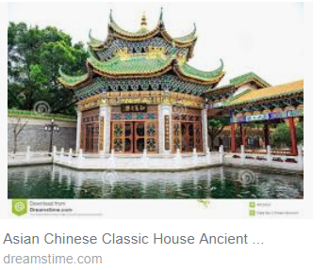
Figure 3: A photo showing a traditional East Asian house of Chinese origin.
Writing and Literature
The East Asian literature comprises of Japanese, Chinese and Korean literature. In the dynasty of Song and Tang, famous poets like Li Bay wrote pertinent works like the shy. These poems have equal-numbered lines. The ci poems, on the other hand, had mixed-numbered lines. The early modern literature of Japan grew comparable innovations like haiku which developed into hokum-both of which are literary forms. The latter has seven syllables whereas the former has five. The Korean literature, on the other hand, is the world’s source of printed papers and featured scripts. The first copper and metal types also emanated from the region (McDaniel, 2015)...
Conclusion
Civilization has led to the growth and development of the East Asia subcontinent. The region has a history of some of the best artistic and architectural backgrounds because of their solidification. Poetry has been one of the main literal forms in the region, particularly emanating from Korea, China, and Japan.

References
Lai, C. K. (2015). Malaya in art and architecture. Inter-Asia Cultural Studies, 16(1), 113-127
McDaniel, J. (2015). Spectacle Attractions and Buddhism in Southeast Asia.

